**Step 1: Sign up into the mobile app**

Enter your credentials and click on signup button

A screenshot of a cell phone

Description generated with very high confidence

**Step 2: Login**

After signing up, enter your email id, password and then click on login button

A screenshot of a cell phone

Description generated with very high confidence

**Step3: Forgot Password**

If you forget your password click on forgot password button in your home page and then enter tour email Id so that your password will be send to your email Id

A screenshot of a cell phone

Description generated with very high confidence

**Step4: Fill registration form**

Fill the registration form after logging in

A screenshot of a cell phone

Description generated with very high confidence

A screenshot of a cell phone

Description generated with very high confidence

A screenshot of a cell phone

Description generated with very high confidence

A screenshot of a cell phone

Description generated with very high confidence

**Step5: Wait for approval**

There will be a progress bar that gets displayed after you fill the registration form is submitted, where the user should wait for the EOC approval.

A screenshot of a cell phone

Description generated with very high confidence

**Step6: Accept/Deny availability notification if an incident occurs.**

Once your application is accepted you will get notifications on the occurrence of any disasters which you will have an option to accept or deny

A screenshot of a cell phone

Description generated with very high confidence

**Step7: View recent or previous disasters**

In the Dashboard various disaster events will be displayed in which by clicking on each event you will go to that specific disaster

A screenshot of a social media post

Description generated with very high confidence

**Step 8: Send Report**

Now we need to go to the report form and send the situation of the disaster effected location, where the first three fields report Id, reported by and Incident will be automatically fetched and we will be having an option to upload the pictures of the affected area taken by the cert member and share the location

A screenshot of a cell phone

Description generated with very high confidence

A screenshot of a cell phone

Description generated with very high confidence

A screenshot of a cell phone

Description generated with very high confidence

The below picture explains about the colors and we just number of people are in that colored situation and the level of structure damage

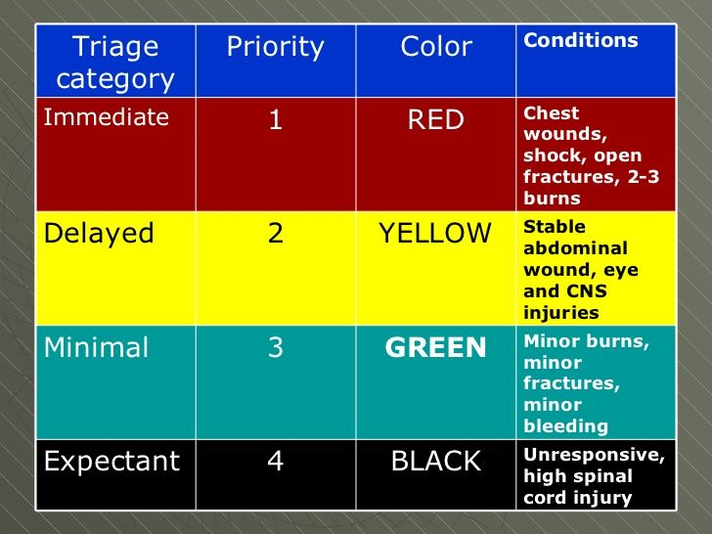

The level of fire should be selected and if there is any threat because of utilities like Electricity, gas , chemical like gas leaking in to air such situations.

A screenshot of a cell phone

Description generated with very high confidence

**HAZMAT** is an abbreviation for “hazardous materials”—substances in quantities or forms that may pose a reasonable risk to health, property, or the environment. HAZMATs include such substances as toxic chemicals, fuels, nuclear waste products, and biological, chemical, and radiological agents.

A screenshot of a cell phone

Description generated with very high confidence

A screenshot of a cell phone

Description generated with very high confidence